**Structures**

Structure - In C/C++, the word "structure" is crucial in the creation of user-defined data types. When objects of potentially diverse kinds are grouped together into one type, a structure provides a data type that may be utilized for this.

*Struct* keyword is used to create a Structure

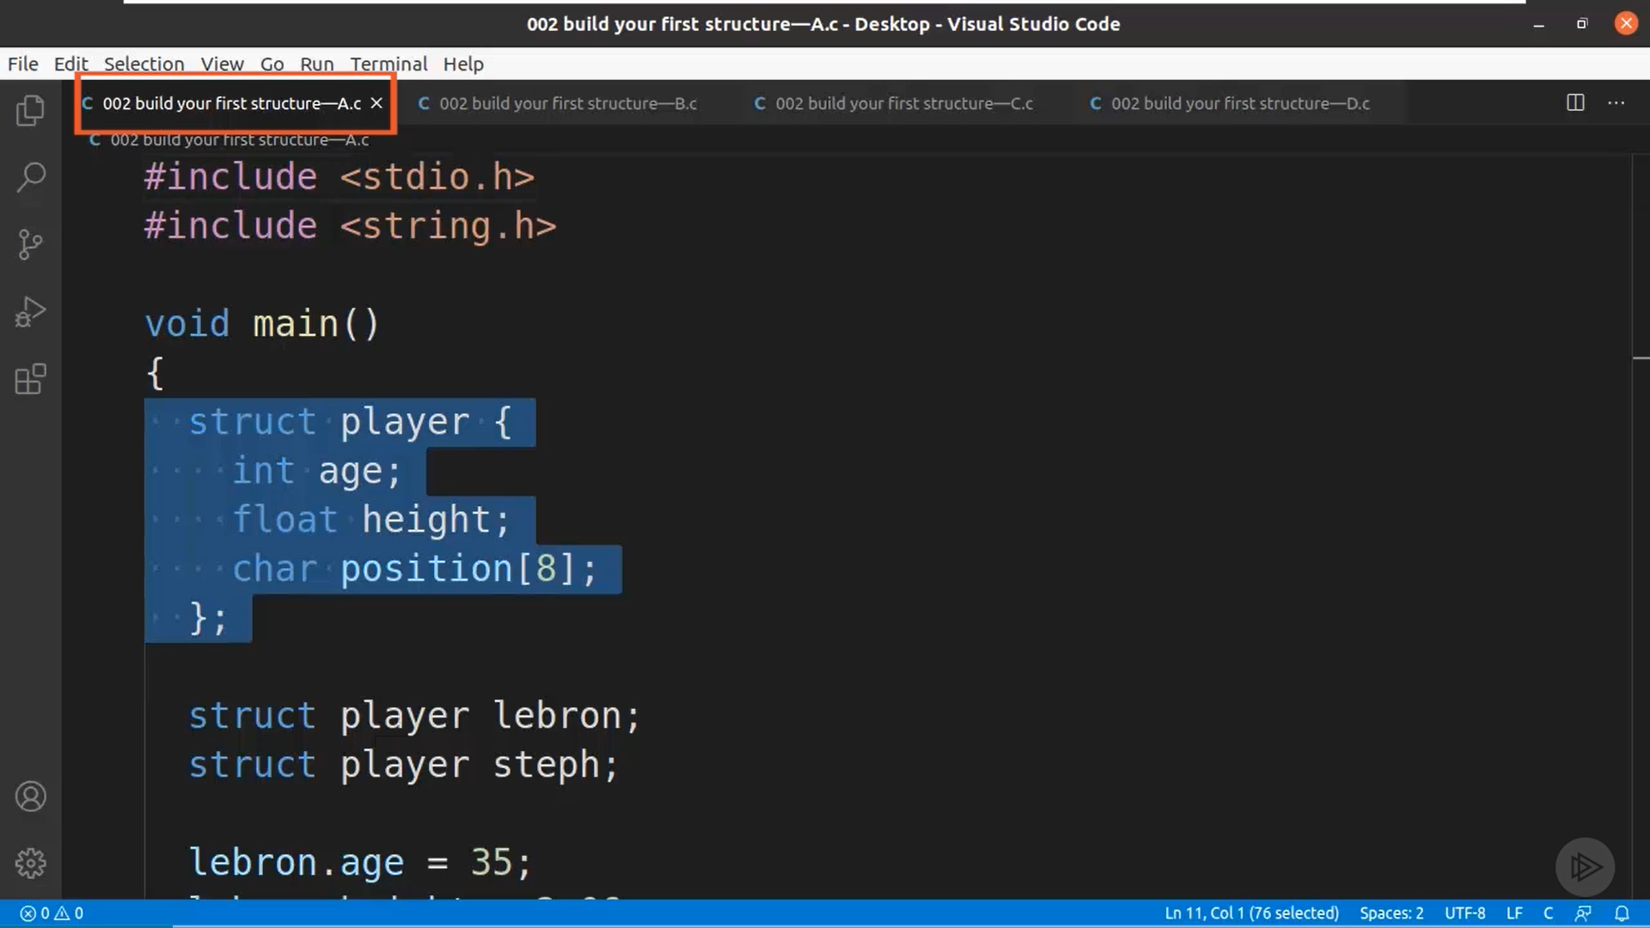

Here we have created a Structure with name Player with data types defined under this structure are age, heigh and position

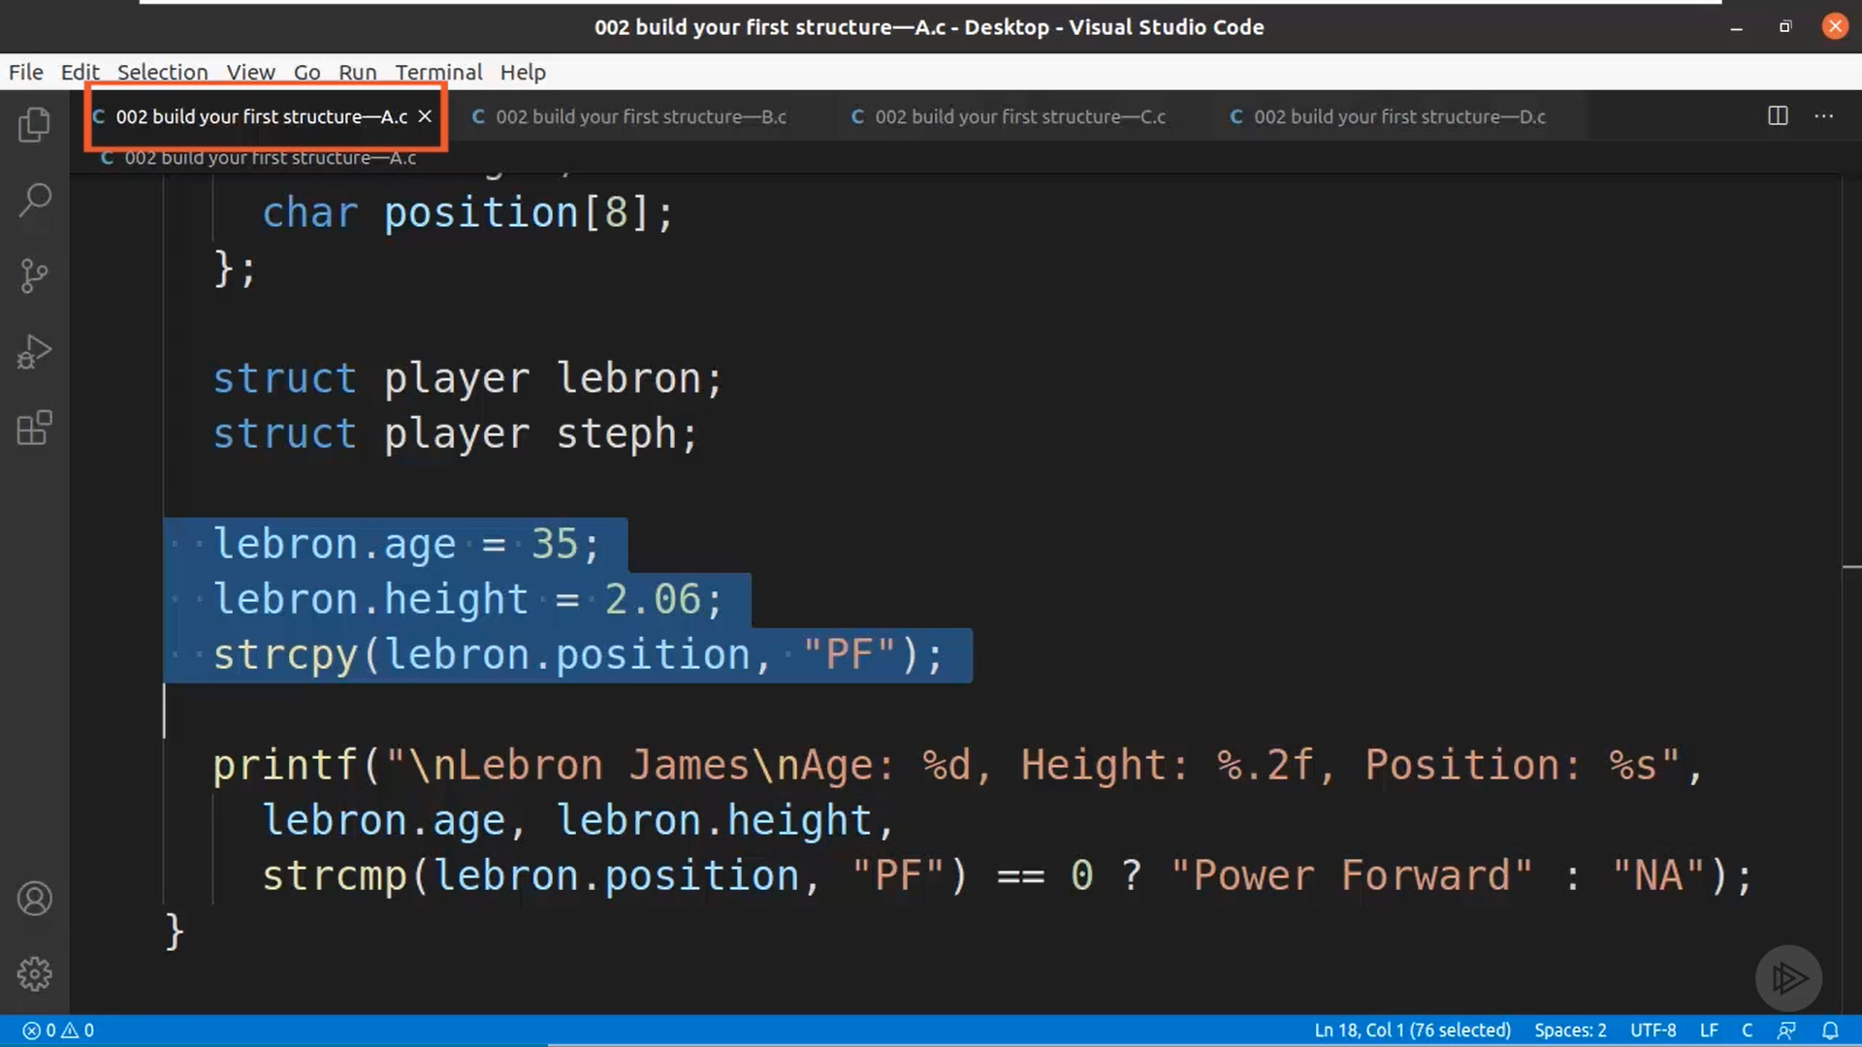

This is how the structure variables are used. We have created a Structure named *Lebron* and *Steph*. We can initialize those variables by using *lebron.age, lebron.height, lebron.position.*

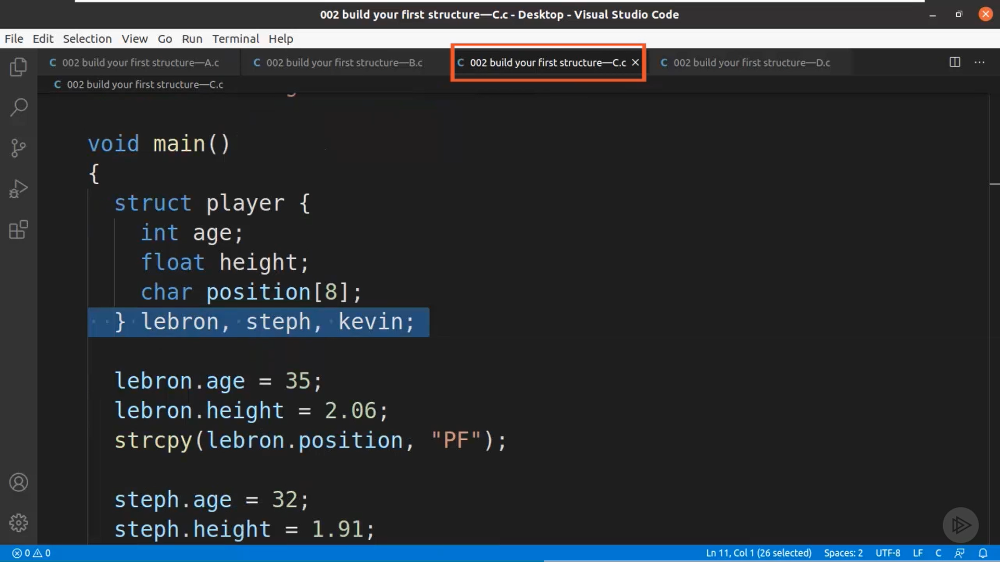

We can define multiple structures like this way

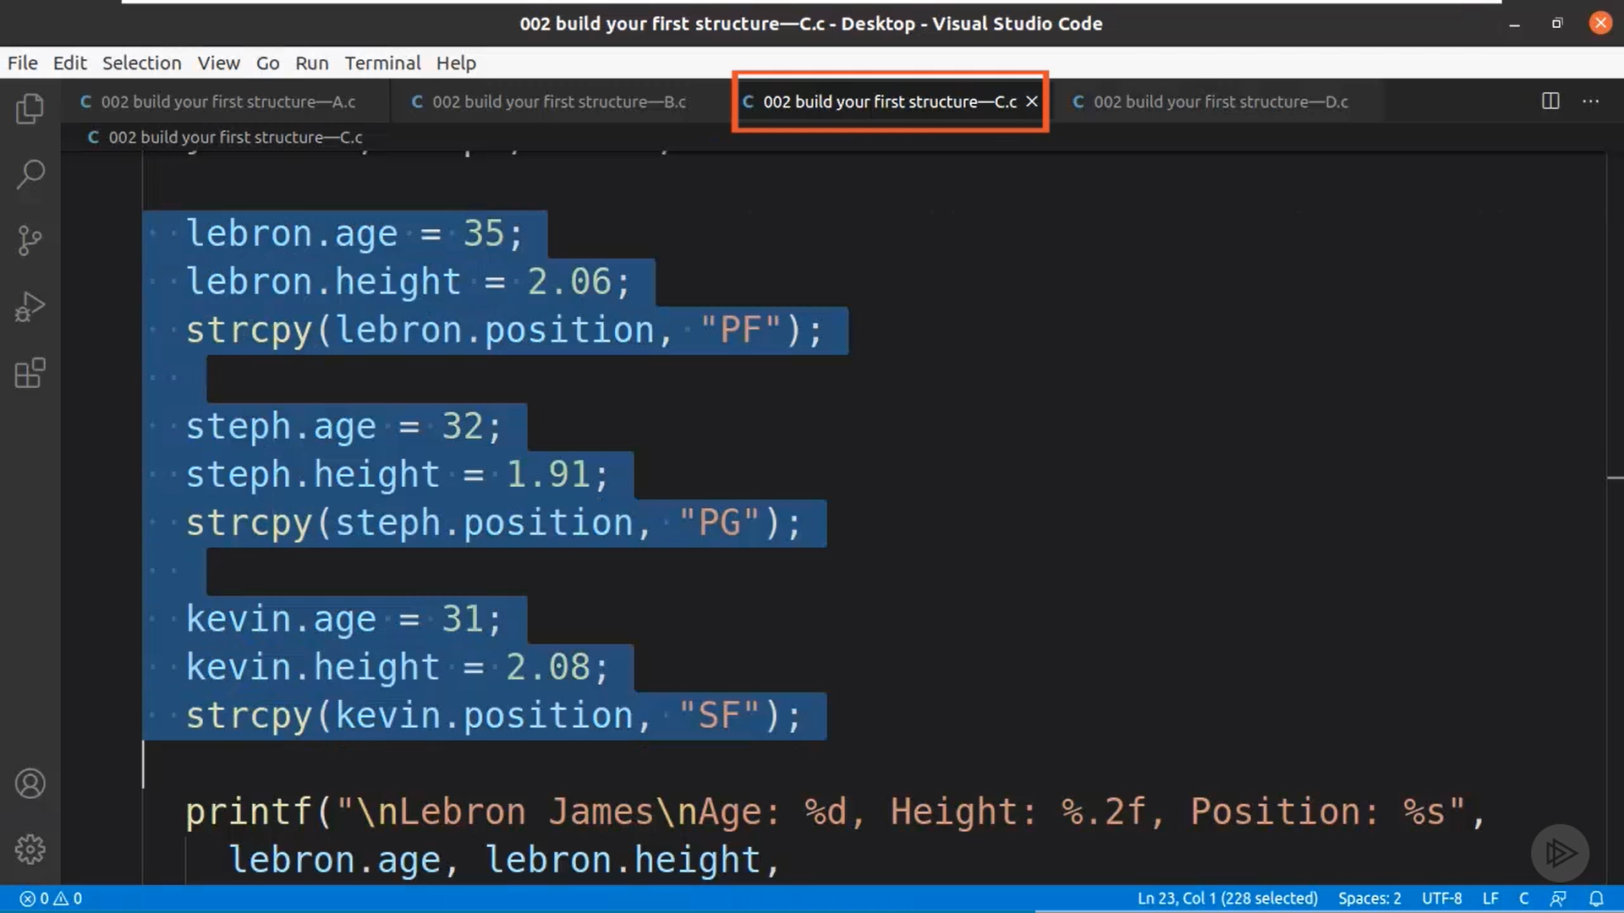

This is how these structures can be provided with values

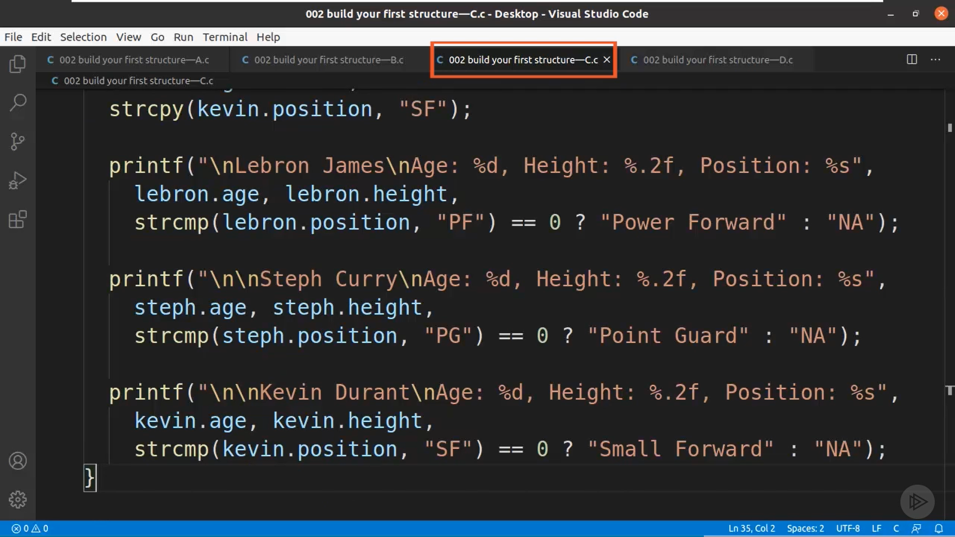

This is how the values of the structures can be printed

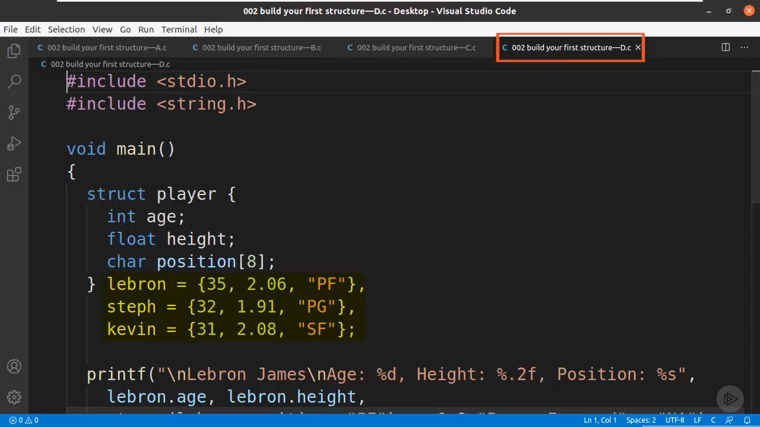

We can also initialize the structures like this.

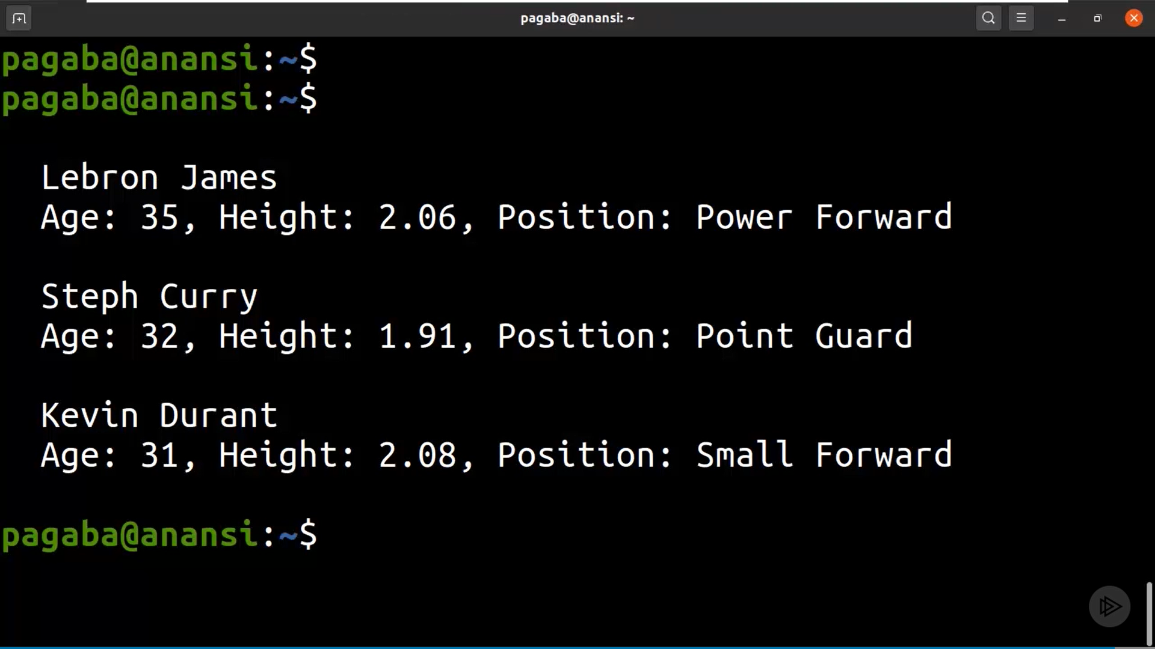

Output of the Above print statements of the Structures

Nested Structures

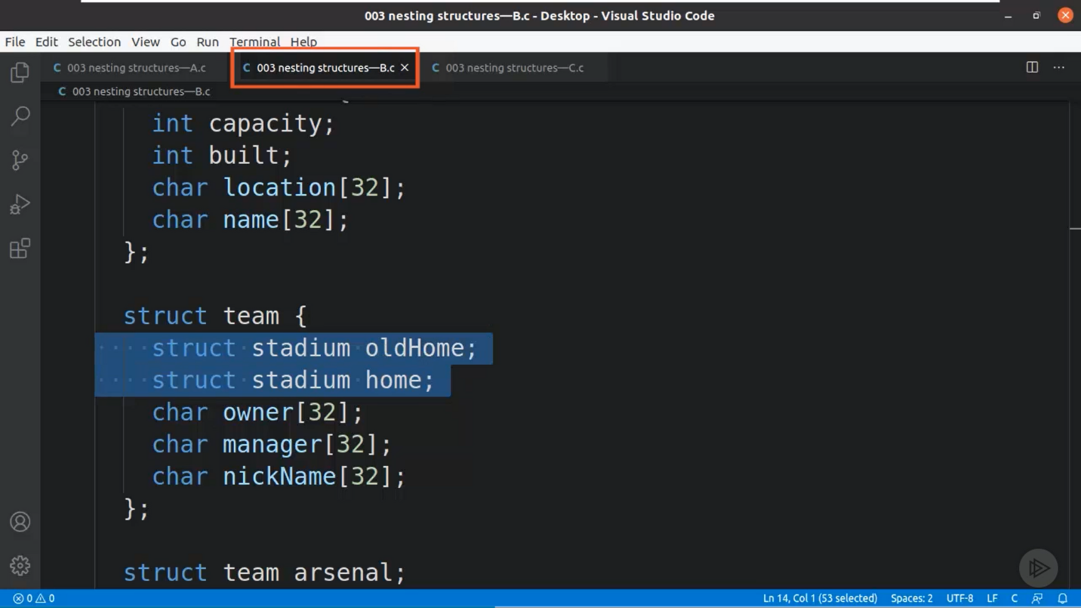

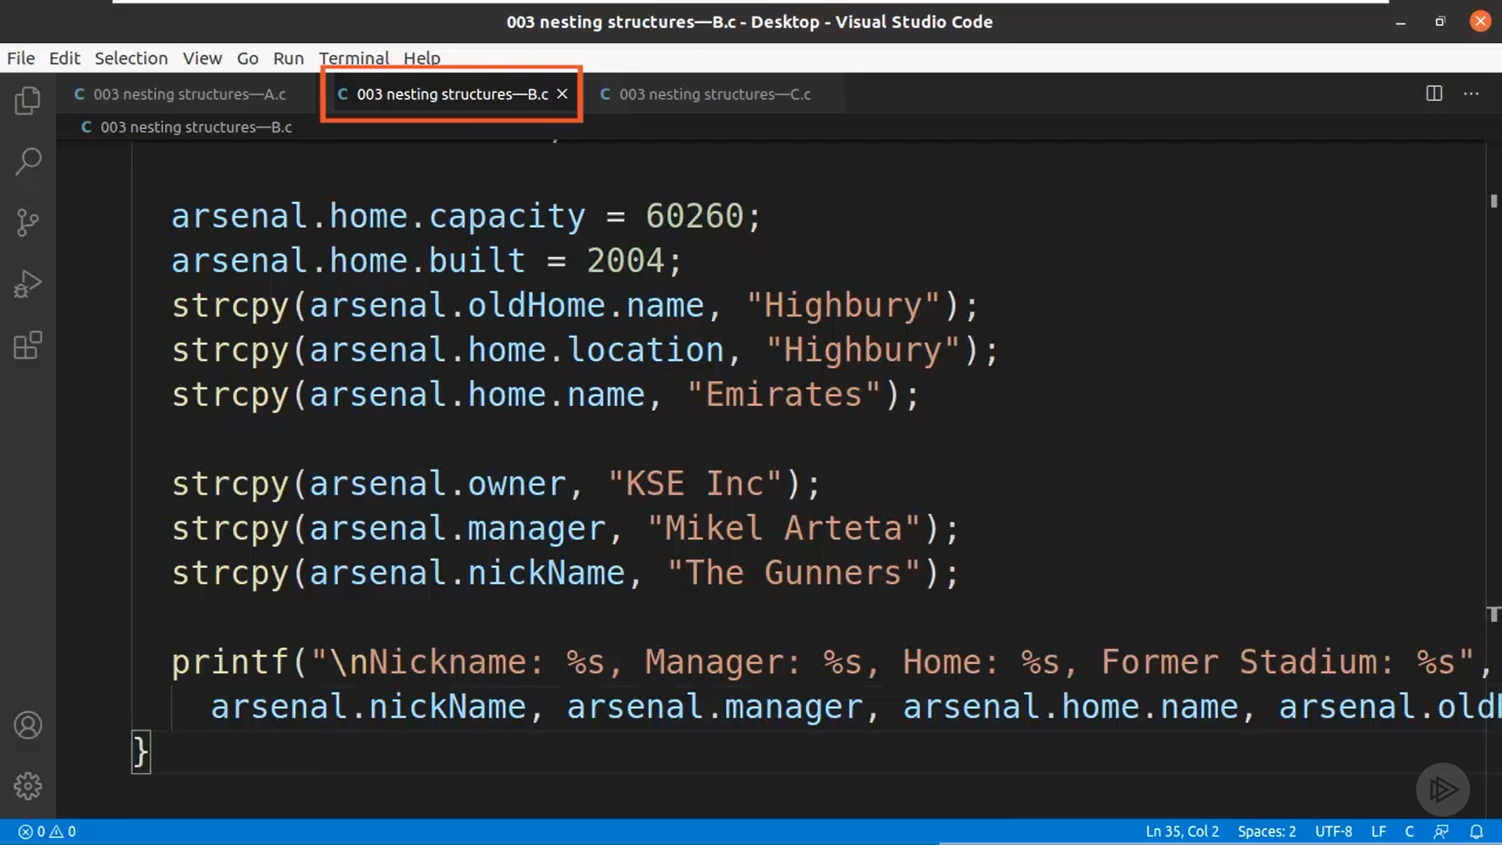

We can nest a Structure inside another structure. Here we have *team* as the first structure and the *stadium* structure is nested inside it. It can be called upon by *team.stadium.variable*

Array of Structures

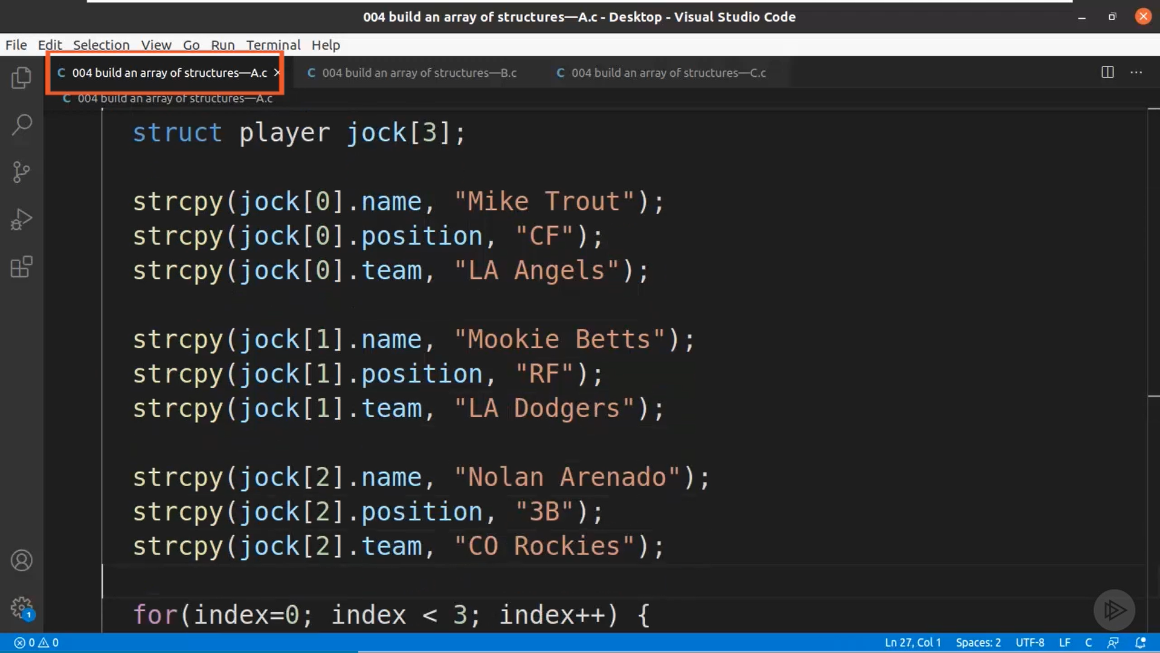

In the Player Structure we have defined array of size 3. This is how can initialize the given array of structures.

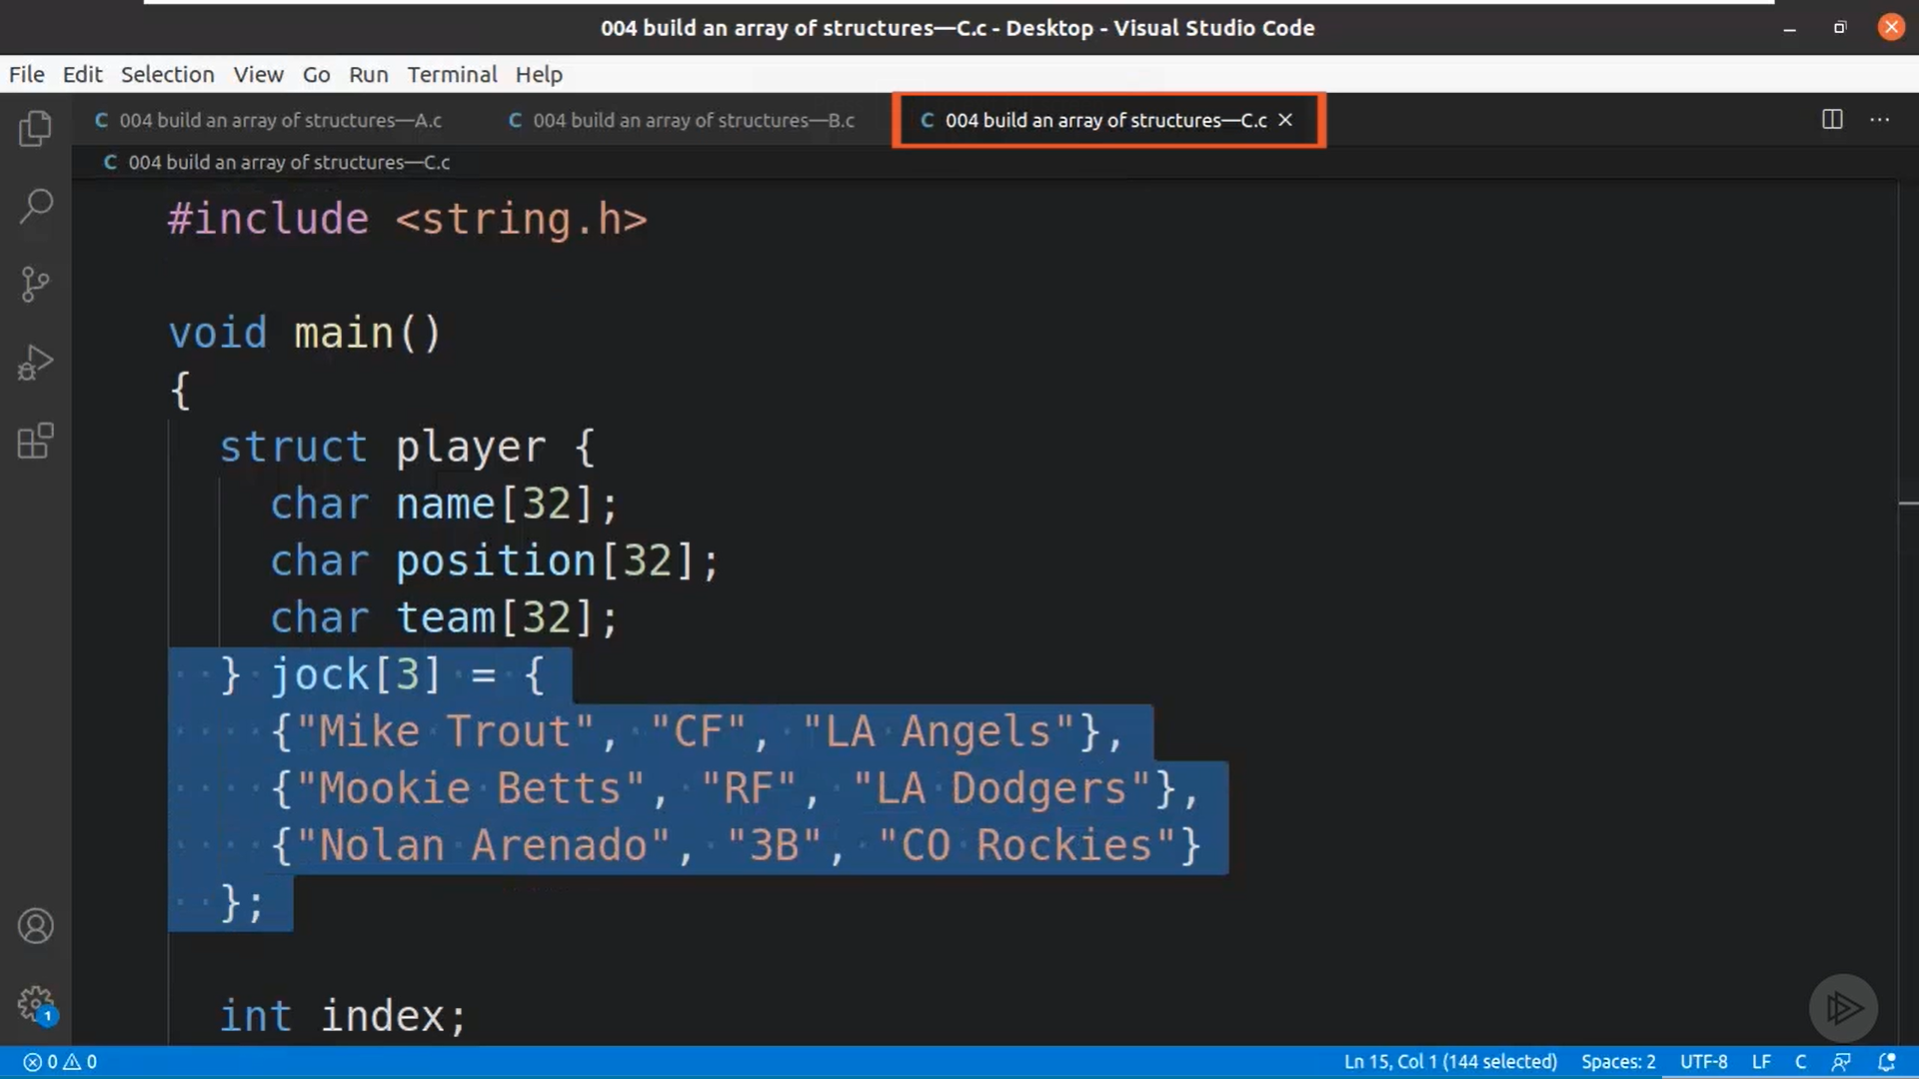

Passing a Structure to a Function

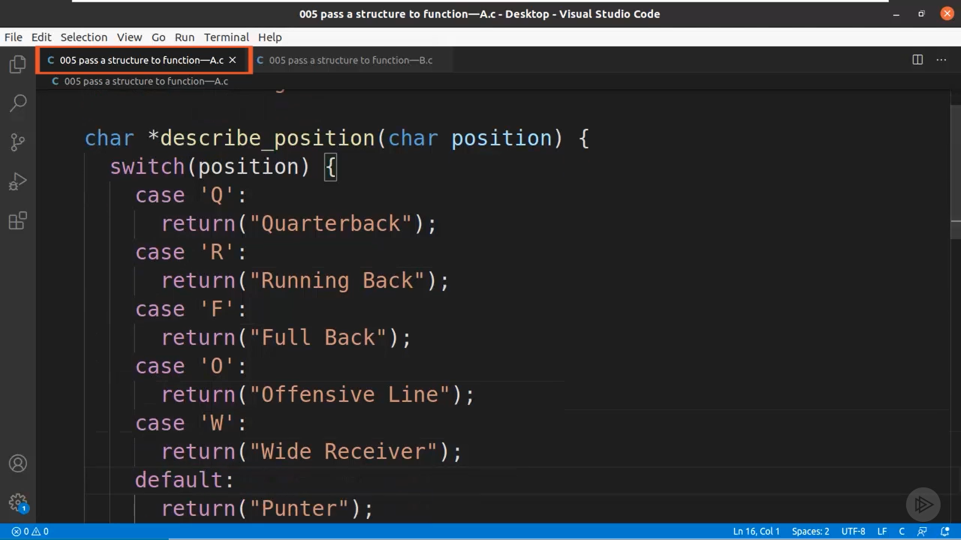

Here we have defined a Function to return a String by looking at the character entered.

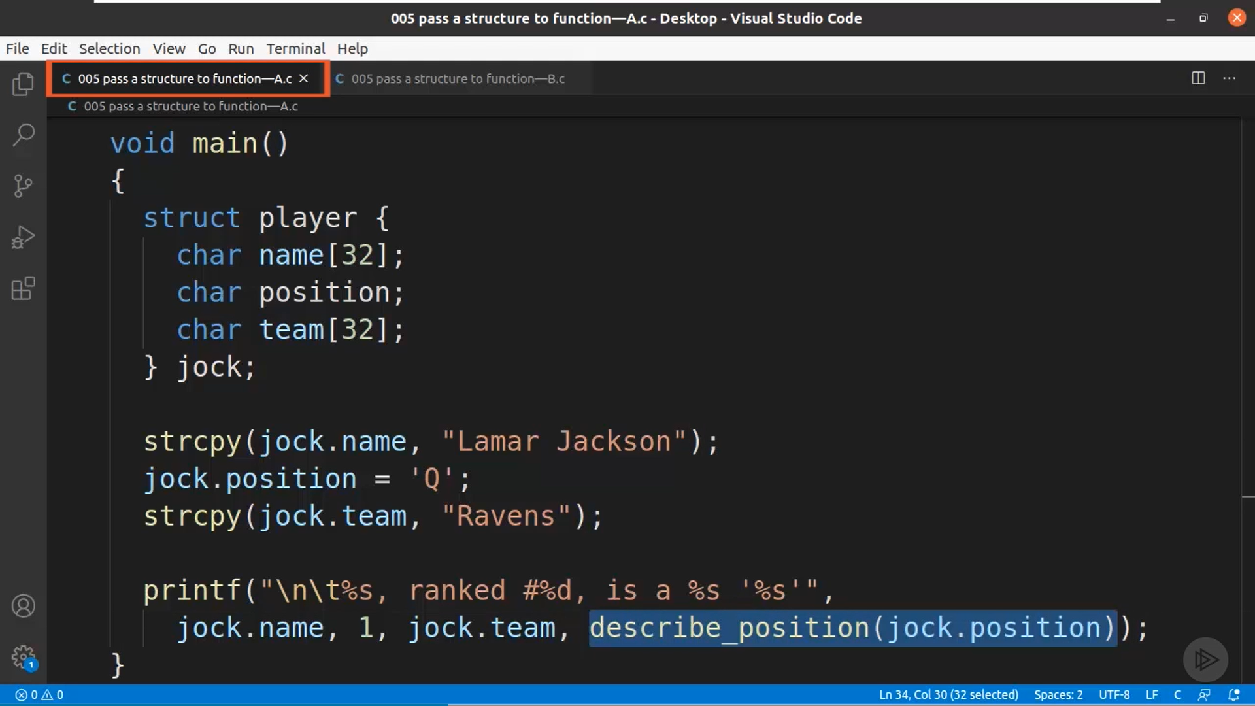

This way we can use structure inside a function.

We can also pass an entire structure inside a function

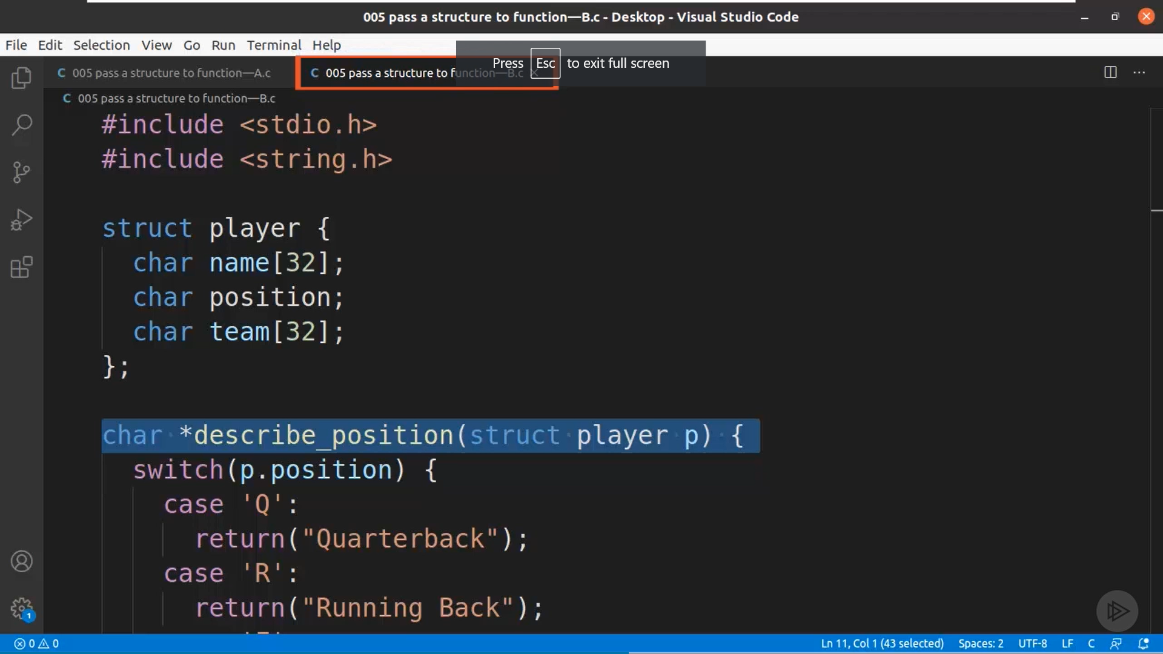

**Pointers**

Pointer – Holds a Memory Location or Address of another variable or contains address of chunk of RAM. Pointer grants access to RAM locations as C is a mid-level language.

Pointers can be defined as

int a;

int *ptr;

a = 18;

ptr = &a

Once defined it can be used with and without asterisk

ptr – Address

*ptr – Value at Address

%p is the address specifier for printing the value of the address

Using Pointers with Arrays:

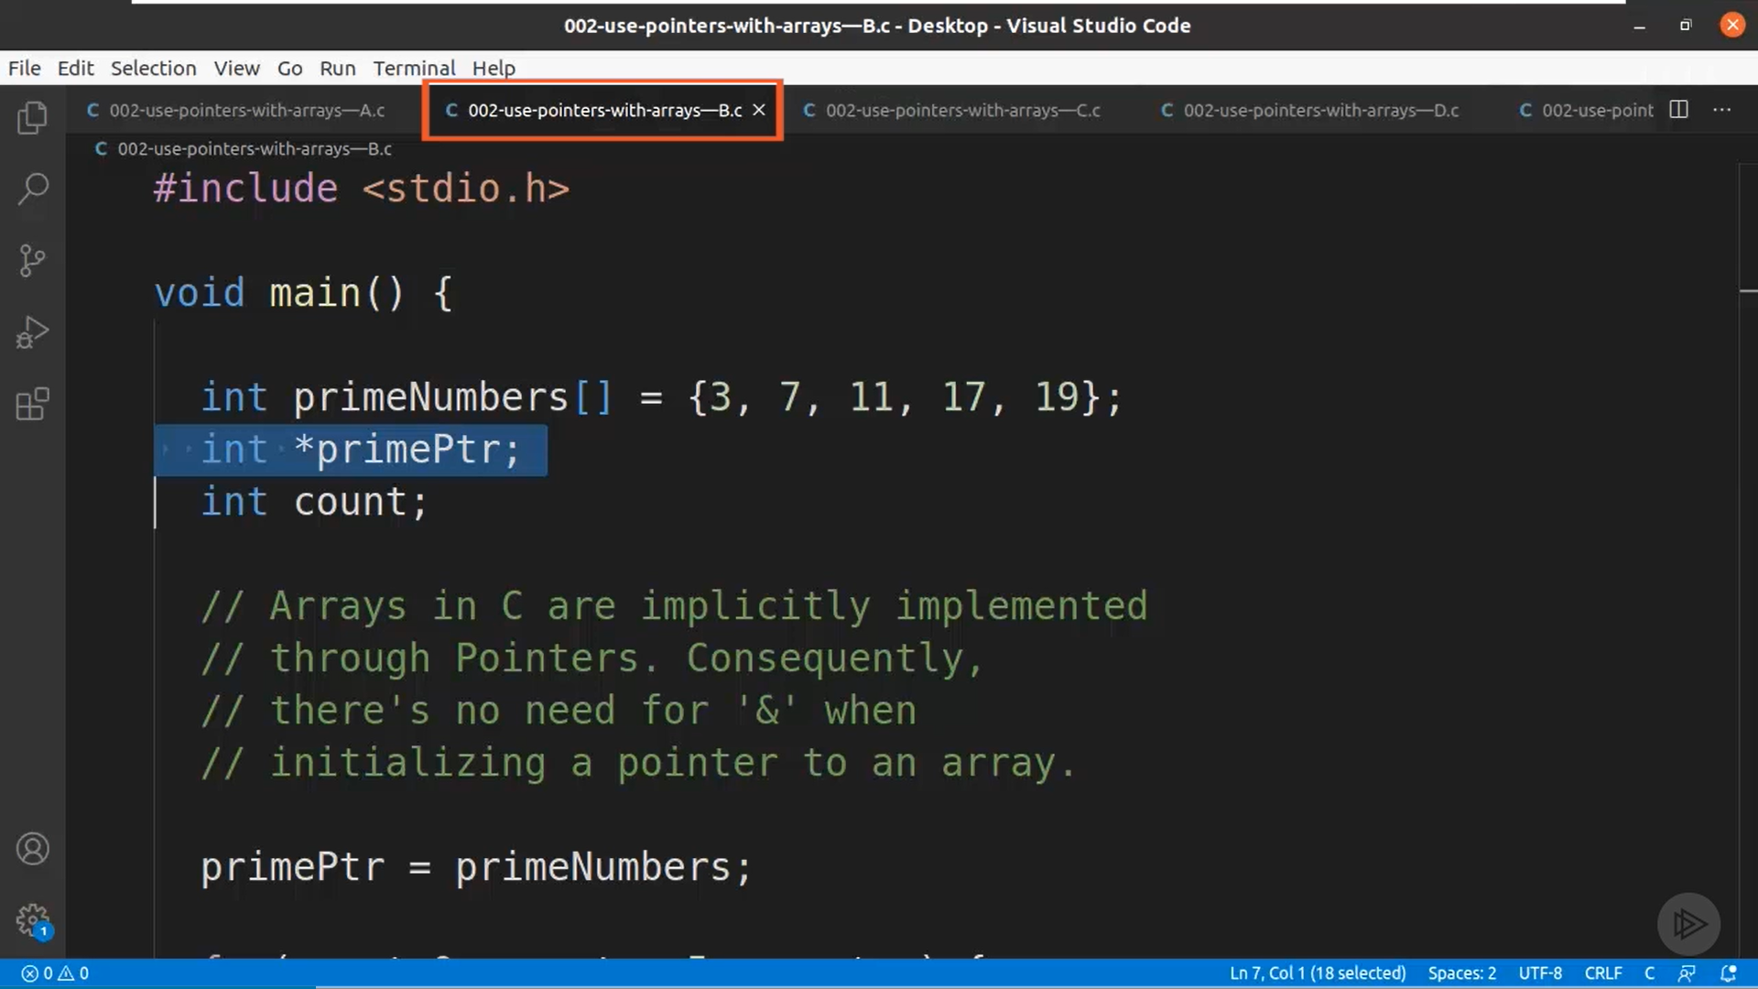Note :- Name of the array can itself be used as a pointer so we don’t have to use *&*

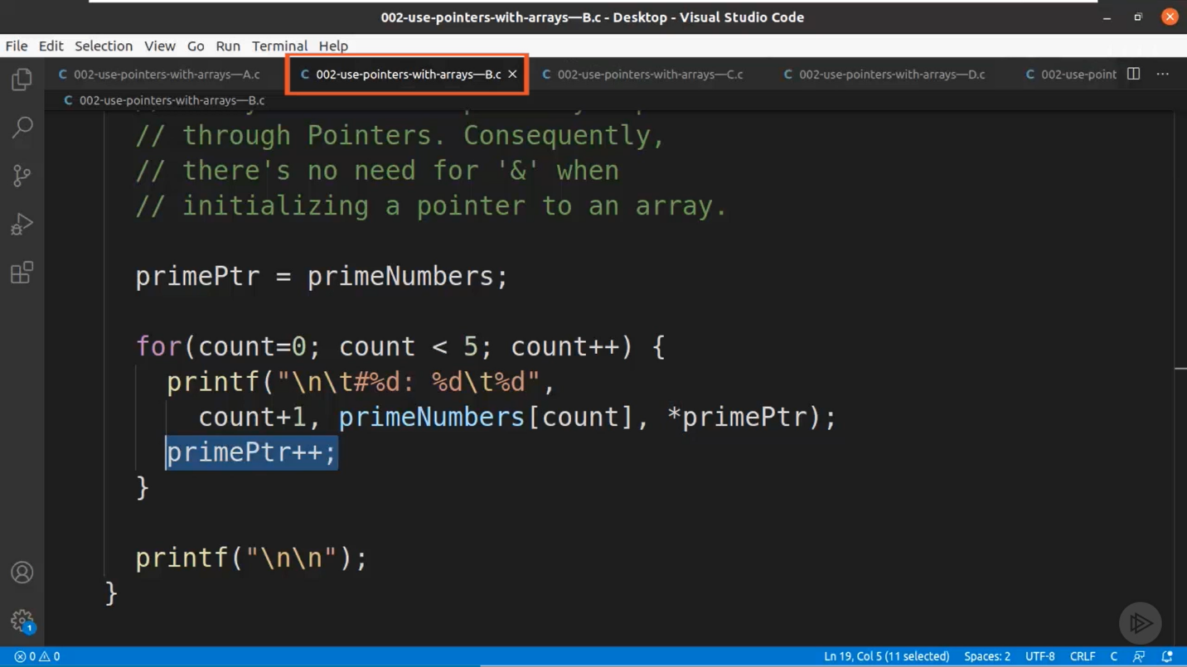

Here *primePtr gives the Value at the address so we get the below given output.

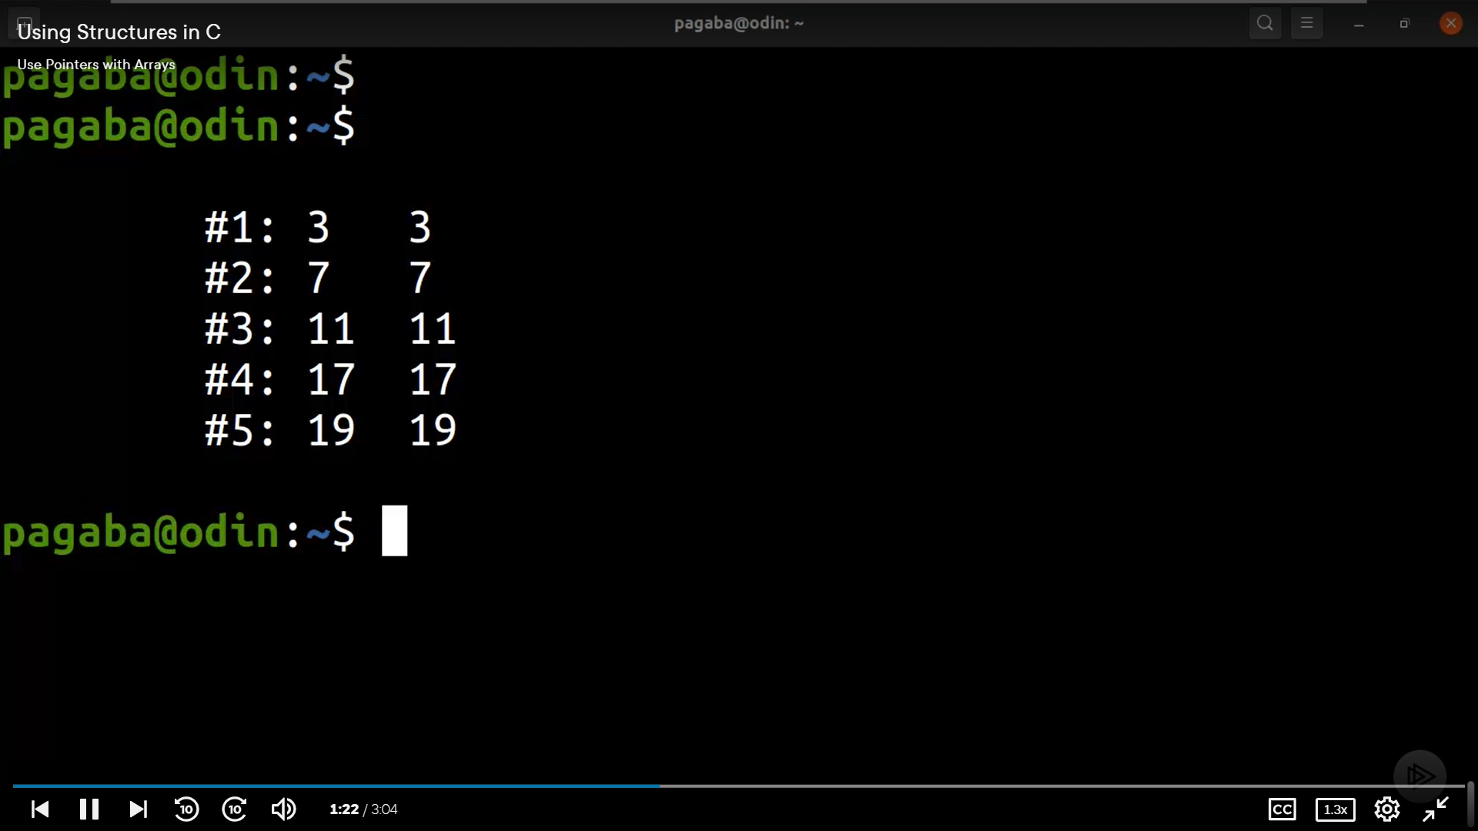

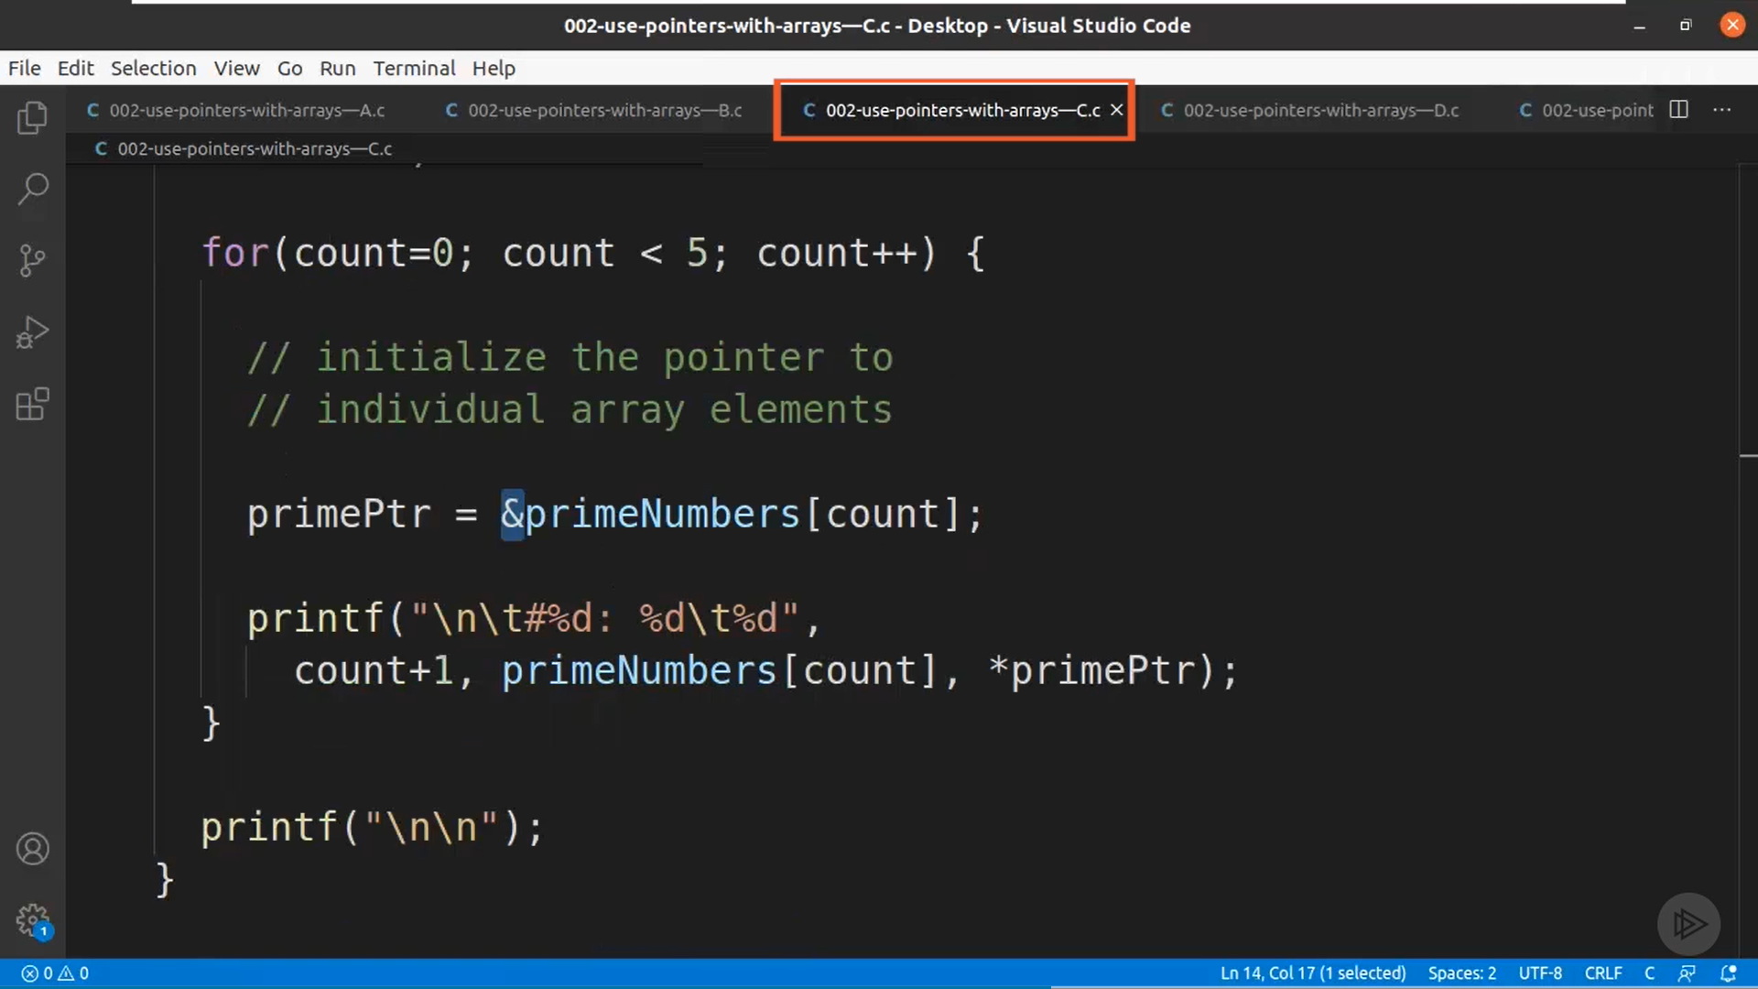

This initializes the pointer to individual array elements.

Originally, Pointer points at the base address of the array.

Pointers with Structures.

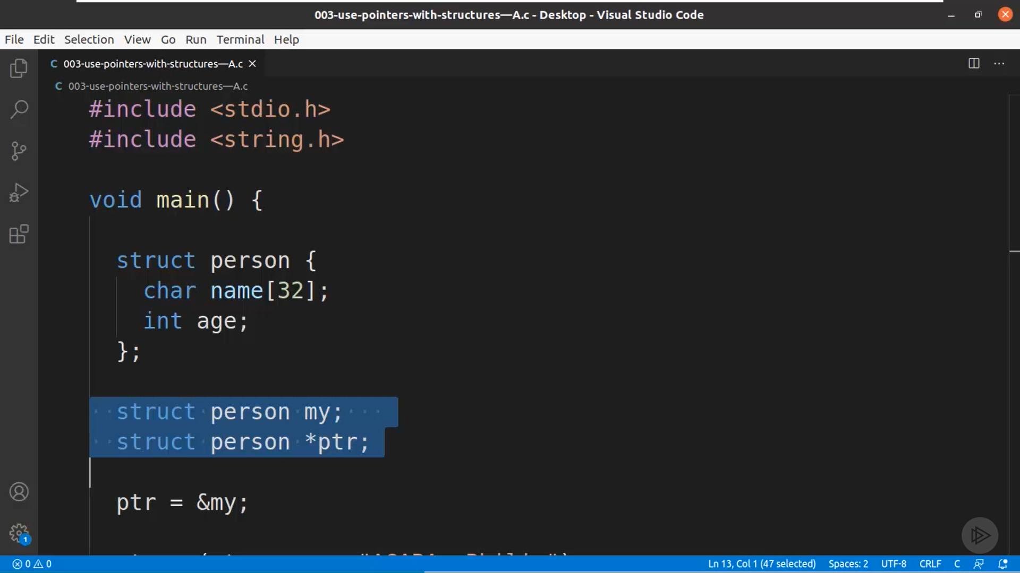

We have created a Structure named Person and then initialized my structure. The pointer stores the value of the structure initialized.

